Necessary tables:

| **Parameter Estimates** | | | | | | | | | | |
| --- | --- | --- | --- | --- | --- | --- | --- | --- | --- | --- |
| **Variable** | **DF** | **Parameter Estimate** | **Standard Error** | **t Value** | **Pr > |t|** | **Squared Semi-partial Corr Type I** | **Squared Semi-partial Corr Type II** | **Variance Inflation** | **99% Confidence Limits** | |
| Intercept | 1 | 64.53528 | 19.49410 | 3.31 | 0.0029 | . | . | 0 | 10.01145 | 119.05910 |
| Runs | 1 | 0.05574 | 0.01569 | 3.55 | 0.0016 | 0.48297 | 0.04421 | 2.10780 | 0.01186 | 0.09962 |
| Hits | 1 | -0.02739 | 0.01094 | -2.50 | 0.0195 | 0.24670 | 0.02193 | 1.61672 | -0.05800 | 0.00322 |
| Walks | 1 | -0.03468 | 0.01022 | -3.39 | 0.0024 | 0.08779 | 0.04036 | 1.25219 | -0.06325 | -0.00611 |
| Errors | 1 | 0.03818 | 0.06970 | 0.55 | 0.5890 | 0.01395 | 0.00105 | 1.41326 | -0.15678 | 0.23313 |
| Saves | 1 | 0.86235 | 0.17549 | 4.91 | <.0001 | 0.08455 | 0.08455 | 3.43636 | 0.37150 | 1.35319 |

Table 1: full model ran using SAS EG [Dependent: Wins, Explanatory: everything else]

|  |
| --- |
| Table 2: Histogram of Residuals  img0.png |
|  |
| Table 3: Fit diagnostics for Residuals and others  img1.png |

| Number of Observations Read | 30 |
| --- | --- |
| Number of Observations Used | 30 |

| **Analysis of Variance** | | | | | |
| --- | --- | --- | --- | --- | --- |
| **Source** | **DF** | **Sum of Squares** | **Mean Square** | **F Value** | **Pr > F** |
| Model | 5 | 3288.28204 | 657.65641 | 52.31 | <.0001 |
| Error | 24 | 301.71796 | 12.57158 |  |  |
| Corrected Total | 29 | 3590.00000 |  |  |  |

| Root MSE | 3.54564 | R-Square | 0.9160 |
| --- | --- | --- | --- |
| Dependent Mean | 81.00000 | Adj R-Sq | 0.8984 |
| Coeff Var | 4.37734 |  |  |

Table 4: Rest of the stuff from regression analysis

The UNIVARIATE Procedure

Variable: Runs

| **Moments** | | | |
| --- | --- | --- | --- |
| **N** | 30 | **Sum Weights** | 30 |
| **Mean** | 745.8 | **Sum Observations** | 22374 |
| **Std Deviation** | 60.9315048 | **Variance** | 3712.64828 |
| **Skewness** | -0.2644524 | **Kurtosis** | -0.6425743 |
| **Uncorrected SS** | 16794196 | **Corrected SS** | 107666.8 |
| **Coeff Variation** | 8.16995237 | **Std Error Mean** | 11.1245199 |

| **Basic Statistical Measures** | | | |
| --- | --- | --- | --- |
| **Location** | | **Variability** | |
| **Mean** | 745.8000 | **Std Deviation** | 60.93150 |
| **Median** | 752.5000 | **Variance** | 3713 |
| **Mode** | 799.0000 | **Range** | 218.00000 |
|  |  | **Interquartile Range** | 85.00000 |

| **Tests for Location: Mu0=0** | | | | |
| --- | --- | --- | --- | --- |
| **Test** | **Statistic** | | **p Value** | |
| **Student's t** | **t** | 67.0411 | **Pr > |t|** | <.0001 |
| **Sign** | **M** | 15 | **Pr >= |M|** | <.0001 |
| **Signed Rank** | **S** | 232.5 | **Pr >= |S|** | <.0001 |

| **Quantiles (Definition 5)** | |
| --- | --- |
| **Level** | **Quantile** |
| **100% Max** | 855.0 |
| **99%** | 855.0 |
| **95%** | 845.0 |
| **90%** | 819.5 |
| **75% Q3** | 789.0 |
| **50% Median** | 752.5 |
| **25% Q1** | 704.0 |
| **10%** | 643.5 |
| **5%** | 640.0 |
| **1%** | 637.0 |
| **0% Min** | 637.0 |

| **Extreme Observations** | | | |
| --- | --- | --- | --- |
| **Lowest** | | **Highest** | |
| **Value** | **Obs** | **Value** | **Obs** |
| 637 | 23 | 805 | 8 |
| 640 | 25 | 810 | 6 |
| 641 | 30 | 829 | 17 |
| 646 | 20 | 845 | 4 |
| 671 | 24 | 855 | 5 |

The UNIVARIATE Procedure

Variable: Hits

| **Moments** | | | |
| --- | --- | --- | --- |
| **N** | 30 | **Sum Weights** | 30 |
| **Mean** | 1461.43333 | **Sum Observations** | 43843 |
| **Std Deviation** | 76.498674 | **Variance** | 5852.04713 |
| **Skewness** | 0.04623872 | **Kurtosis** | -0.6143474 |
| **Uncorrected SS** | 64243331 | **Corrected SS** | 169709.367 |
| **Coeff Variation** | 5.23449632 | **Std Error Mean** | 13.9666831 |

| **Basic Statistical Measures** | | | |
| --- | --- | --- | --- |
| **Location** | | **Variability** | |
| **Mean** | 1461.433 | **Std Deviation** | 76.49867 |
| **Median** | 1460.500 | **Variance** | 5852 |
| **Mode** | 1415.000 | **Range** | 302.00000 |
|  |  | **Interquartile Range** | 115.00000 |

| **Tests for Location: Mu0=0** | | | | |
| --- | --- | --- | --- | --- |
| **Test** | **Statistic** | | **p Value** | |
| **Student's t** | **t** | 104.6371 | **Pr > |t|** | <.0001 |
| **Sign** | **M** | 15 | **Pr >= |M|** | <.0001 |
| **Signed Rank** | **S** | 232.5 | **Pr >= |S|** | <.0001 |

| **Quantiles (Definition 5)** | |
| --- | --- |
| **Level** | **Quantile** |
| **100% Max** | 1631.0 |
| **99%** | 1631.0 |
| **95%** | 1563.0 |
| **90%** | 1545.5 |
| **75% Q3** | 1530.0 |
| **50% Median** | 1460.5 |
| **25% Q1** | 1415.0 |
| **10%** | 1356.5 |
| **5%** | 1330.0 |
| **1%** | 1329.0 |
| **0% Min** | 1329.0 |

| **Extreme Observations** | | | |
| --- | --- | --- | --- |
| **Lowest** | | **Highest** | |
| **Value** | **Obs** | **Value** | **Obs** |
| 1329 | 5 | 1542 | 7 |
| 1330 | 29 | 1544 | 24 |
| 1349 | 27 | 1547 | 9 |
| 1364 | 20 | 1563 | 17 |
| 1369 | 4 | 1631 | 22 |

The UNIVARIATE Procedure

Variable: Walks

| **Moments** | | | |
| --- | --- | --- | --- |
| **N** | 30 | **Sum Weights** | 30 |
| **Mean** | 544.366667 | **Sum Observations** | 16331 |
| **Std Deviation** | 72.1227322 | **Variance** | 5201.68851 |
| **Skewness** | 0.08112201 | **Kurtosis** | -0.7048531 |
| **Uncorrected SS** | 9040901 | **Corrected SS** | 150848.967 |
| **Coeff Variation** | 13.2489252 | **Std Error Mean** | 13.1677491 |

| **Basic Statistical Measures** | | | |
| --- | --- | --- | --- |
| **Location** | | **Variability** | |
| **Mean** | 544.3667 | **Std Deviation** | 72.12273 |
| **Median** | 548.0000 | **Variance** | 5202 |
| **Mode** | 457.0000 | **Range** | 284.00000 |
|  |  | **Interquartile Range** | 99.00000 |

|  |
| --- |
| **Note: The mode displayed is the smallest of 3 modes with a count of 2.** |

| **Tests for Location: Mu0=0** | | | | |
| --- | --- | --- | --- | --- |
| **Test** | **Statistic** | | **p Value** | |
| **Student's t** | **t** | 41.34091 | **Pr > |t|** | <.0001 |
| **Sign** | **M** | 15 | **Pr >= |M|** | <.0001 |
| **Signed Rank** | **S** | 232.5 | **Pr >= |S|** | <.0001 |

| **Quantiles (Definition 5)** | |
| --- | --- |
| **Level** | **Quantile** |
| **100% Max** | 687 |
| **99%** | 687 |
| **95%** | 657 |
| **90%** | 648 |
| **75% Q3** | 588 |
| **50% Median** | 548 |
| **25% Q1** | 489 |
| **10%** | 454 |
| **5%** | 444 |
| **1%** | 403 |
| **0% Min** | 403 |

| **Extreme Observations** | | | |
| --- | --- | --- | --- |
| **Lowest** | | **Highest** | |
| **Value** | **Obs** | **Value** | **Obs** |
| 403 | 17 | 626 | 24 |
| 444 | 8 | 644 | 10 |
| 451 | 1 | 652 | 25 |
| 457 | 14 | 657 | 22 |
| 457 | 6 | 687 | 3 |

The UNIVARIATE Procedure

Variable: Errors

| **Moments** | | | |
| --- | --- | --- | --- |
| **N** | 30 | **Sum Weights** | 30 |
| **Mean** | 96.9666667 | **Sum Observations** | 2909 |
| **Std Deviation** | 11.229528 | **Variance** | 126.102299 |
| **Skewness** | -0.3463058 | **Kurtosis** | 0.37027681 |
| **Uncorrected SS** | 285733 | **Corrected SS** | 3656.96667 |
| **Coeff Variation** | 11.5808126 | **Std Error Mean** | 2.05022193 |

| **Basic Statistical Measures** | | | |
| --- | --- | --- | --- |
| **Location** | | **Variability** | |
| **Mean** | 96.96667 | **Std Deviation** | 11.22953 |
| **Median** | 97.00000 | **Variance** | 126.10230 |
| **Mode** | 96.00000 | **Range** | 50.00000 |
|  |  | **Interquartile Range** | 17.00000 |

| **Tests for Location: Mu0=0** | | | | |
| --- | --- | --- | --- | --- |
| **Test** | **Statistic** | | **p Value** | |
| **Student's t** | **t** | 47.29569 | **Pr > |t|** | <.0001 |
| **Sign** | **M** | 15 | **Pr >= |M|** | <.0001 |
| **Signed Rank** | **S** | 232.5 | **Pr >= |S|** | <.0001 |

| **Quantiles (Definition 5)** | |
| --- | --- |
| **Level** | **Quantile** |
| **100% Max** | 117.0 |
| **99%** | 117.0 |
| **95%** | 114.0 |
| **90%** | 113.0 |
| **75% Q3** | 107.0 |
| **50% Median** | 97.0 |
| **25% Q1** | 90.0 |
| **10%** | 83.5 |
| **5%** | 83.0 |
| **1%** | 67.0 |
| **0% Min** | 67.0 |

| **Extreme Observations** | | | |
| --- | --- | --- | --- |
| **Lowest** | | **Highest** | |
| **Value** | **Obs** | **Value** | **Obs** |
| 67 | 12 | 108 | 17 |
| 83 | 19 | 113 | 1 |
| 83 | 18 | 113 | 10 |
| 84 | 29 | 114 | 7 |
| 85 | 26 | 117 | 11 |

The UNIVARIATE Procedure

Variable: Saves

| **Moments** | | | |
| --- | --- | --- | --- |
| **N** | 30 | **Sum Weights** | 30 |
| **Mean** | 34.9 | **Sum Observations** | 1047 |
| **Std Deviation** | 6.95478005 | **Variance** | 48.3689655 |
| **Skewness** | 0.44654508 | **Kurtosis** | -1.1699342 |
| **Uncorrected SS** | 37943 | **Corrected SS** | 1402.7 |
| **Coeff Variation** | 19.9277365 | **Std Error Mean** | 1.2697633 |

| **Basic Statistical Measures** | | | |
| --- | --- | --- | --- |
| **Location** | | **Variability** | |
| **Mean** | 34.90000 | **Std Deviation** | 6.95478 |
| **Median** | 33.00000 | **Variance** | 48.36897 |
| **Mode** | 28.00000 | **Range** | 21.00000 |
|  |  | **Interquartile Range** | 12.00000 |

| **Tests for Location: Mu0=0** | | | | |
| --- | --- | --- | --- | --- |
| **Test** | **Statistic** | | **p Value** | |
| **Student's t** | **t** | 27.48544 | **Pr > |t|** | <.0001 |
| **Sign** | **M** | 15 | **Pr >= |M|** | <.0001 |
| **Signed Rank** | **S** | 232.5 | **Pr >= |S|** | <.0001 |

| **Quantiles (Definition 5)** | |
| --- | --- |
| **Level** | **Quantile** |
| **100% Max** | 47 |
| **99%** | 47 |
| **95%** | 47 |
| **90%** | 46 |
| **75% Q3** | 40 |
| **50% Median** | 33 |
| **25% Q1** | 28 |
| **10%** | 27 |
| **5%** | 27 |
| **1%** | 26 |
| **0% Min** | 26 |

| **Extreme Observations** | | | |
| --- | --- | --- | --- |
| **Lowest** | | **Highest** | |
| **Value** | **Obs** | **Value** | **Obs** |
| 26 | 24 | 44 | 5 |
| 27 | 30 | 45 | 16 |
| 27 | 22 | 47 | 4 |
| 27 | 10 | 47 | 14 |
| 28 | 23 | 47 | 21 |

|  |
| --- |
| “How Normal is the Runs Histogram?” |

The UNIVARIATE Procedure

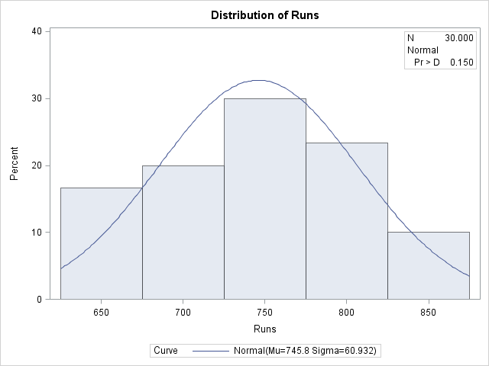

|  |
| --- |
| “How Normal is the Runs Histogram?” |

The UNIVARIATE Procedure

Fitted Normal Distribution for Runs

| **Parameters for Normal Distribution** | | |
| --- | --- | --- |
| **Parameter** | **Symbol** | **Estimate** |
| **Mean** | Mu | 745.8 |
| **Std Dev** | Sigma | 60.9315 |

| **Goodness-of-Fit Tests for Normal Distribution** | | | | |
| --- | --- | --- | --- | --- |
| **Test** | **Statistic** | | **p Value** | |
| **Kolmogorov-Smirnov** | **D** | 0.10785636 | **Pr > D** | >0.150 |
| **Cramer-von Mises** | **W-Sq** | 0.04070354 | **Pr > W-Sq** | >0.250 |
| **Anderson-Darling** | **A-Sq** | 0.30332249 | **Pr > A-Sq** | >0.250 |

| **Histogram Bin Percents for Normal Distribution** | | |
| --- | --- | --- |
| **Bin Midpoint** | **Percent** | |
| **Observed** | **Estimated** |
| **650** | 16.667 | 9.892 |
| **700** | 20.000 | 24.379 |
| **750** | 30.000 | 31.770 |
| **800** | 23.333 | 21.906 |
| **850** | 10.000 | 7.985 |

| **Quantiles for Normal Distribution** | | |
| --- | --- | --- |
| **Percent** | **Quantile** | |
| **Observed** | **Estimated** |
| **20.0** | 695.500 | 694.519 |
| **40.0** | 741.000 | 730.363 |
| **60.0** | 767.500 | 761.237 |
| **80.0** | 799.000 | 797.081 |

|  |
| --- |
| “How Normal is the Hits Histogram?” |

The UNIVARIATE Procedure

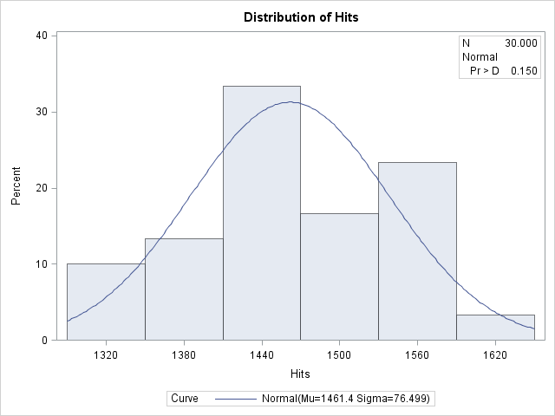

|  |
| --- |
| “How Normal is the Hits Histogram?” |

The UNIVARIATE Procedure

Fitted Normal Distribution for Hits

| **Parameters for Normal Distribution** | | |
| --- | --- | --- |
| **Parameter** | **Symbol** | **Estimate** |
| **Mean** | Mu | 1461.433 |
| **Std Dev** | Sigma | 76.49867 |

| **Goodness-of-Fit Tests for Normal Distribution** | | | | |
| --- | --- | --- | --- | --- |
| **Test** | **Statistic** | | **p Value** | |
| **Kolmogorov-Smirnov** | **D** | 0.09952865 | **Pr > D** | >0.150 |
| **Cramer-von Mises** | **W-Sq** | 0.04086855 | **Pr > W-Sq** | >0.250 |
| **Anderson-Darling** | **A-Sq** | 0.29862212 | **Pr > A-Sq** | >0.250 |

| **Histogram Bin Percents for Normal Distribution** | | |
| --- | --- | --- |
| **Bin Midpoint** | **Percent** | |
| **Observed** | **Estimated** |
| **1320** | 10.000 | 6.009 |
| **1380** | 13.333 | 17.808 |
| **1440** | 33.333 | 29.390 |
| **1500** | 16.667 | 27.037 |
| **1560** | 23.333 | 13.863 |
| **1620** | 3.333 | 3.957 |

| **Quantiles for Normal Distribution** | | |
| --- | --- | --- |
| **Percent** | **Quantile** | |
| **Observed** | **Estimated** |
| **20.0** | 1392.00 | 1397.05 |
| **40.0** | 1441.50 | 1442.05 |
| **60.0** | 1475.50 | 1480.81 |
| **80.0** | 1539.50 | 1525.82 |

|  |
| --- |
| “How Normal is the Walks Histogram?” |

The UNIVARIATE Procedure

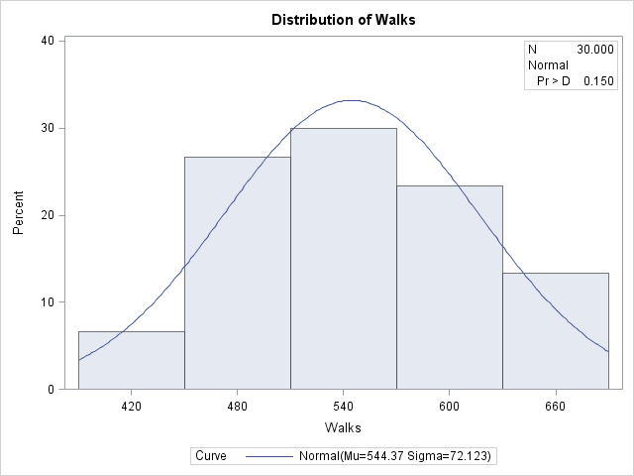

|  |
| --- |
| “How Normal is the Walks Histogram?” |

The UNIVARIATE Procedure

Fitted Normal Distribution for Walks

| **Parameters for Normal Distribution** | | |
| --- | --- | --- |
| **Parameter** | **Symbol** | **Estimate** |
| **Mean** | Mu | 544.3667 |
| **Std Dev** | Sigma | 72.12273 |

| **Goodness-of-Fit Tests for Normal Distribution** | | | | |
| --- | --- | --- | --- | --- |
| **Test** | **Statistic** | | **p Value** | |
| **Kolmogorov-Smirnov** | **D** | 0.08210078 | **Pr > D** | >0.150 |
| **Cramer-von Mises** | **W-Sq** | 0.02729705 | **Pr > W-Sq** | >0.250 |
| **Anderson-Darling** | **A-Sq** | 0.20276599 | **Pr > A-Sq** | >0.250 |

| **Histogram Bin Percents for Normal Distribution** | | |
| --- | --- | --- |
| **Bin Midpoint** | **Percent** | |
| **Observed** | **Estimated** |
| **420** | 6.667 | 7.920 |
| **480** | 26.667 | 22.149 |
| **540** | 30.000 | 32.200 |
| **600** | 23.333 | 24.359 |
| **660** | 13.333 | 9.582 |

| **Quantiles for Normal Distribution** | | |
| --- | --- | --- |
| **Percent** | **Quantile** | |
| **Observed** | **Estimated** |
| **20.0** | 473.500 | 483.667 |
| **40.0** | 527.000 | 526.095 |
| **60.0** | 561.500 | 562.639 |
| **80.0** | 607.500 | 605.067 |

|  |
| --- |
| “How Normal is the Errors Histogram?” |

The UNIVARIATE Procedure

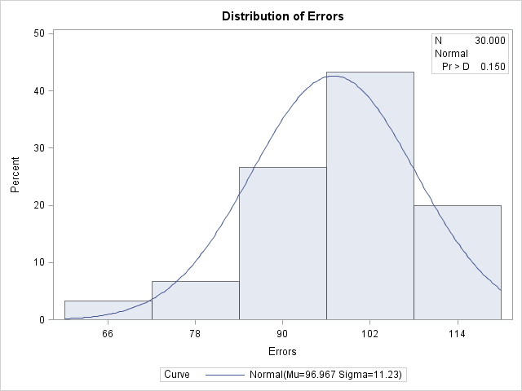

|  |
| --- |
| “How Normal is the Errors Histogram?” |

The UNIVARIATE Procedure

Fitted Normal Distribution for Errors

| **Parameters for Normal Distribution** | | |
| --- | --- | --- |
| **Parameter** | **Symbol** | **Estimate** |
| **Mean** | Mu | 96.96667 |
| **Std Dev** | Sigma | 11.22953 |

| **Goodness-of-Fit Tests for Normal Distribution** | | | | |
| --- | --- | --- | --- | --- |
| **Test** | **Statistic** | | **p Value** | |
| **Kolmogorov-Smirnov** | **D** | 0.09903372 | **Pr > D** | >0.150 |
| **Cramer-von Mises** | **W-Sq** | 0.04223229 | **Pr > W-Sq** | >0.250 |
| **Anderson-Darling** | **A-Sq** | 0.30091978 | **Pr > A-Sq** | >0.250 |

| **Histogram Bin Percents for Normal Distribution** | | |
| --- | --- | --- |
| **Bin Midpoint** | **Percent** | |
| **Observed** | **Estimated** |
| **66** | 3.333 | 1.260 |
| **78** | 6.667 | 11.101 |
| **90** | 26.667 | 34.159 |
| **102** | 43.333 | 37.138 |
| **114** | 20.000 | 14.279 |

| **Quantiles for Normal Distribution** | | |
| --- | --- | --- |
| **Percent** | **Quantile** | |
| **Observed** | **Estimated** |
| **20.0** | 87.0000 | 87.5157 |
| **40.0** | 96.0000 | 94.1217 |
| **60.0** | 99.0000 | 99.8116 |
| **80.0** | 107.5000 | 106.4177 |

|  |
| --- |
| “How Normal is the Saves Histogram?” |

The UNIVARIATE Procedure

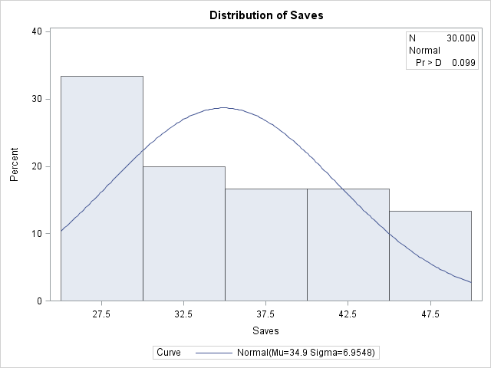

|  |
| --- |
| “How Normal is the Saves Histogram?” |

The UNIVARIATE Procedure

Fitted Normal Distribution for Saves

| **Parameters for Normal Distribution** | | |
| --- | --- | --- |
| **Parameter** | **Symbol** | **Estimate** |
| **Mean** | Mu | 34.9 |
| **Std Dev** | Sigma | 6.95478 |

| **Goodness-of-Fit Tests for Normal Distribution** | | | | |
| --- | --- | --- | --- | --- |
| **Test** | **Statistic** | | **p Value** | |
| **Kolmogorov-Smirnov** | **D** | 0.14585459 | **Pr > D** | 0.099 |
| **Cramer-von Mises** | **W-Sq** | 0.13516641 | **Pr > W-Sq** | 0.037 |
| **Anderson-Darling** | **A-Sq** | 0.90576089 | **Pr > A-Sq** | 0.020 |

| **Histogram Bin Percents for Normal Distribution** | | |
| --- | --- | --- |
| **Bin Midpoint** | **Percent** | |
| **Observed** | **Estimated** |
| **27.5** | 33.333 | 16.325 |
| **32.5** | 20.000 | 26.519 |
| **37.5** | 16.667 | 26.258 |
| **42.5** | 16.667 | 15.847 |
| **47.5** | 13.333 | 5.826 |

| **Quantiles for Normal Distribution** | | |
| --- | --- | --- |
| **Percent** | **Quantile** | |
| **Observed** | **Estimated** |
| **20.0** | 28.0000 | 29.0467 |
| **40.0** | 31.0000 | 33.1380 |
| **60.0** | 36.5000 | 36.6620 |
| **80.0** | 42.0000 | 40.7533 |